Name: Fiction: Explicit Meaning – Q1:3 Date:

*As you answer this week’s questions, highlight your evidence in the text.*

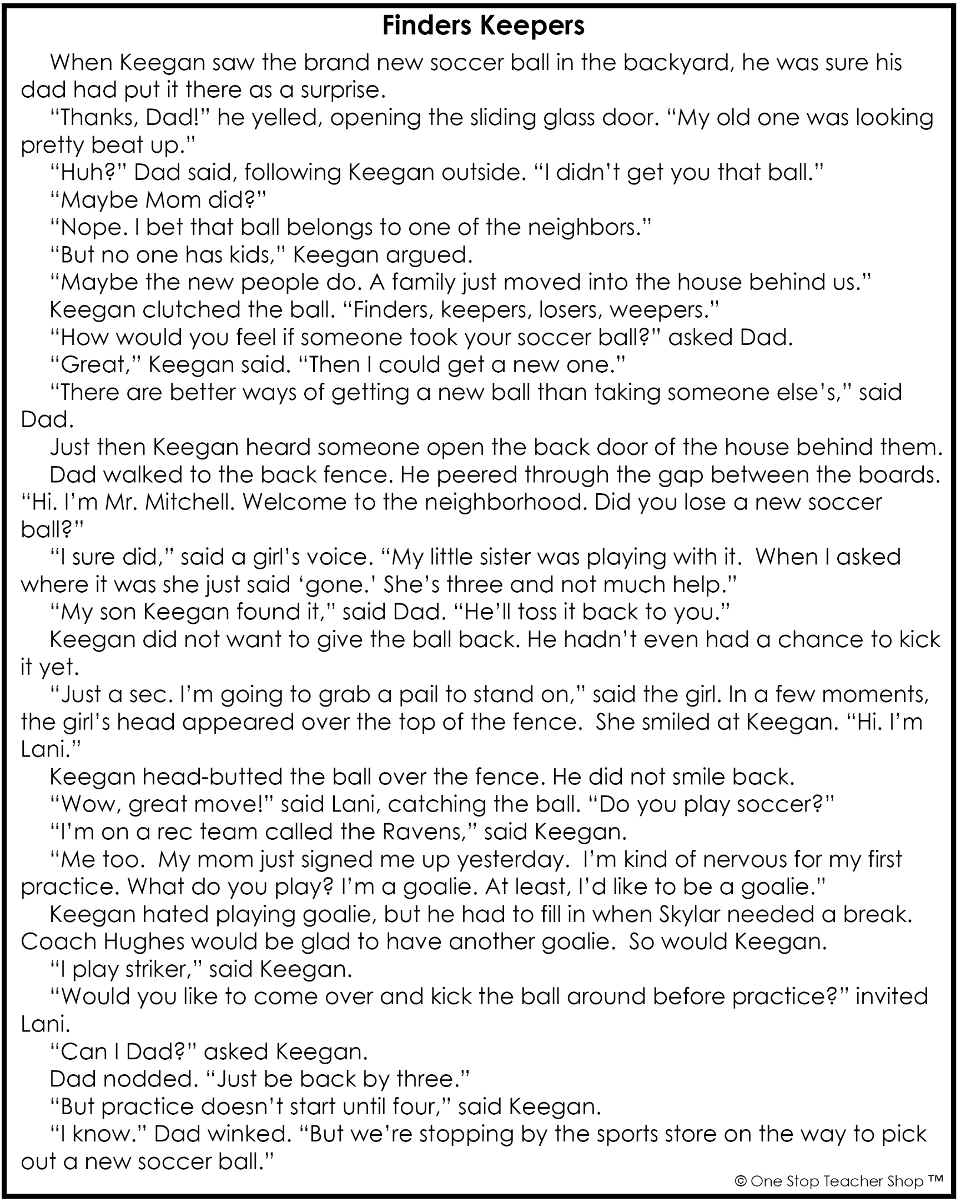

Fiction: Explicit Meaning – Q1:3

|  |  |
| --- | --- |
| **Monday** | **Tuesday** |
| **Before** you read, make a prediction about this story based on the title.  ___________________________________________ | When Keegan first saw the new soccer ball in his backyard, where did he think it came from? |
| Using a timer, see how long it takes you to read the entire text. Record your time below. Ask someone for help.  _______ minutes _______ seconds | At the beginning of the story, where does Keegan’s dad think the ball came from?  ___________________________________________ |
| Who are the characters in the story?  ___________________________________________ | What does Keegan mean when he says, “Finder, keepers, losers, weepers.”?  ___________________________________________ |
| Where does the story take place?  ___________________________________________ | Why did Keegan say he would be happy if someone took his soccer ball?  ___________________________________________ |
| **Wednesday** | **Thursday** |
| Who did the soccer ball belong to?  ___________________________________________ | Using a timer, see how long it takes you to read the entire story. Record your time below. Did your time improve?  _______ minutes _______ seconds |
| Who was responsible for losing the soccer ball?  ___________________________________________ | How does Lani feel about her first soccer practice?  ___________________________________________ |
| What did Keegan do to send the ball back over the fence to Lani?  ___________________________________________ | Why was Keegan glad to have another goalie on the team?  ___________________________________________ |
| What is the name of Keegan’s soccer team?  ___________________________________________ | Besides getting a new soccer ball, what else did Keegan gain in this story?  ___________________________________________ |

More of My Thinking

|  |  |
| --- | --- |
| Monday | Tuesday |
| __________________________________________________________________________________________________________________________________________________________________________________________________________________________________________________________________ | __________________________________________________________________________________________________________________________________________________________________________________________________________________________________________________________________ |
| Wednesday | Thursday |
| __________________________________________________________________________________________________________________________________________________________________________________________________________________________________________________________________ | __________________________________________________________________________________________________________________________________________________________________________________________________________________________________________________________________ |

My Progress

|  |  |  |  |
| --- | --- | --- | --- |
| MONDAY  _____ out of 4 correct  I need more help with…  _____________________  _____________________ _____________________ | TUESDAY  _____ out of 4 correct  I need more help with…  _____________________  _____________________ _____________________ | WEDNESDAY  _____ out of 4 correct  I need more help with…  _____________________  _____________________ _____________________ | THURSDAY  _____ out of 4 correct  I need more help with…  _____________________  _____________________ _____________________ |